

**A2: Squatty Potty: Assessing Digital Marketing Campaign Data**

**By Team 6**

**Master of Business Analytics, Hult International Business School**

**Marketing Analytics - DAT-6033 - VNA1**

**Instructor: Professor.** [**Matthew Fisher**](https://mycourses.hult.edu/courses/3389968/users/9147097)

**Submission: 06-18-2023**

**Authors: Ordonez, G., Turbi, M., Pragnyashree Patra, Parvez, T.**

**Summary**:

We analyzed the Squatty Potty digital marketing campaign data to assess its effectiveness and uncover potential strategies for future promotional endeavors. Our primary objective was to evaluate parameters such as result rate, cost per result, total promotional spend, and engagement metrics to gauge the campaign's performance. By analyzing the data, we have formulated several recommendations for future campaigns. These include targeting untapped audience segments, exploring alternative advertising styles through experimentation, and incorporating promotional offers or discounts.

**1. Using the data included in the spreadsheet, rate the overall efficacy of the campaign by any criteria you deem relevant (justify why you use whatever your choose). Where possible, apply specific numbers to the criteria.**

To effectively measure the campaign's effectiveness, it is crucial to quantify both the financial and non-financial return on promotional expenditure. In the case of the Squatty Potty campaign, providing clear visibility of the data, both in financial and non-financial terms, becomes a key consideration for stakeholders. The 2016 financial report revealed approximately $4.8 million in earnings, indicating a substantial return on investment (ROI) of around 21% for that year. Assessing the overall campaign period from October 2015 to December 2016, the ROI reached an impressive 304%, further emphasizing the campaign's success. The Return on Advertising Spend (ROAS) also stood at approximately 622%, underscoring the significant financial profitability of the viral video campaign.

Furthermore, non-financial data, such as social media shares and exposure rates, played a vital role in evaluating the campaign's effectiveness. Following the launch of the viral video, Squatty Potty garnered around 125 billion views on Facebook and 31 billion views on YouTube, signifying extensive exposure. The video effectively introduced the product to a vast audience and enhanced brand awareness. Increased awareness is crucial as it is the initial step towards generating purchases, as those who encounter the brand online may become potential buyers of Squatty Potty. Moreover, the humorous video advertisement piqued consumer curiosity, encouraging them to explore Squatty Potty's website. Thus, the video campaign has paved the way for Squatty Potty's continued success and is poised to bring further benefits in the future.

The campaign's overall effectiveness is highly successful. This conclusion is based on several criteria, including the significant financial profit generated and the notable increase in social awareness for both the product and the brand. In 2016 alone, the campaign achieved a remarkable profit of $4,828,897.94. Furthermore, the campaign exhibited a strong presence across social media platforms, with impressive YouTube and Facebook View to share ratios of 43.7 and 74.7, respectively. Notably, the viral video production cost amounted to $1,985,604.33, but the resulting sales from that video reached $12,944,694.40, indicating a substantial margin of success and a profit of $10,959,090.07. Additionally, the campaign has yielded valuable data that can be utilized for future reference and consideration.

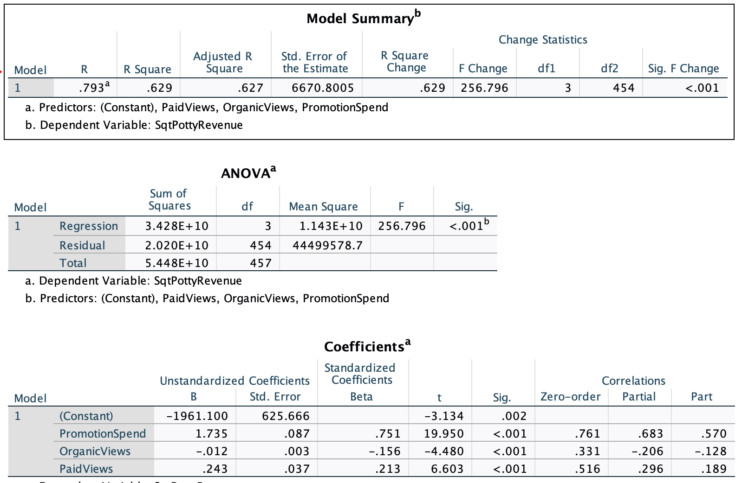

Run a linear regression to identify the impact of the statistics, which gave us an adjusted R squared of .627, showing how revenue has grown from social media marketing.

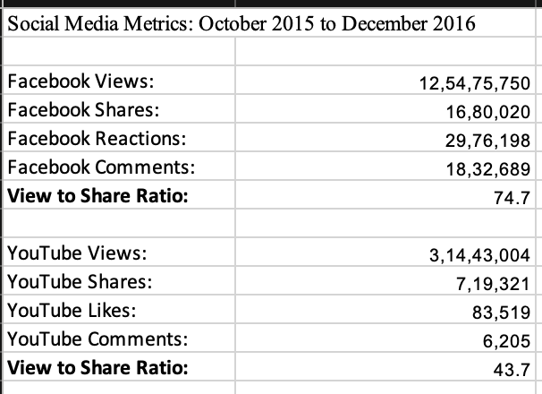

**2. Using the data in the Excel spreadsheets, create a 12-month forecast for a new follow-up viral video from Squatty Potty to be released January 1, 2017. List your assumptions for the forecast based on the historical data and any other information you can find. Additionally, calculate what you believe are the relevant marketing and financial metrics for this forecast.**

The new viral video from Squatty Potty, which will be released on January 1, 2017, was given a 12-month prediction, and it was found that the prognosis showed a constant trend in views and revenue with no noticeable ups and downs. The Excel spreadsheets' historical data and any extra pertinent data are the foundation for the forecast's presumptions. Some of the presumptions might be:

* **Historical Trend**: The projection assumes that the past performance of Squatty Potty's popular videos is a reliable predictor of the future. This suggests that the elements that made the prior videos successful—creative content, successful marketing tactics, and audience engagement—will also be responsible for the new follow-up video's viewership and financial success.
* **Similar Audience Reach**: According to the prediction, the new Squatty Potty follow-up video will aim to reach the same demographic as its predecessors. This presupposes that the target audience won't change and that the video will appeal to the audience already in place, resulting in a steady stream of views.
* **Marketing Efforts**: The prediction makes the assumption that Squatty Potty will use successful marketing strategies to advertise the new follow-up video. Increasing the video's exposure and impact can entail using social media platforms, influencer alliances, targeted advertising, and other marketing initiatives.

The following financial indicators could be pertinent for this forecast:

* **Revenue**: The forecast should project how much money the video will bring in. This could include earnings from product sales, brand collaborations, ad placements, or any other monetization techniques used in connection with the video.
* **Cost of Production**: The video's production costs, such as those for creative development, filming, editing, and other production expenditures, may be considered in the forecast. Understanding the production costs enables one to assess the video campaign's profitability.

Squatty Potty can learn more about the anticipated performance and effects of the new viral video campaign by implementing these hypotheses and monitoring the pertinent marketing and financial KPIs. The campaign plan can be optimized, and the desired results can be achieved by routinely reviewing and modifying the anticipated metrics based on real-time data.

Forecast of Revenue

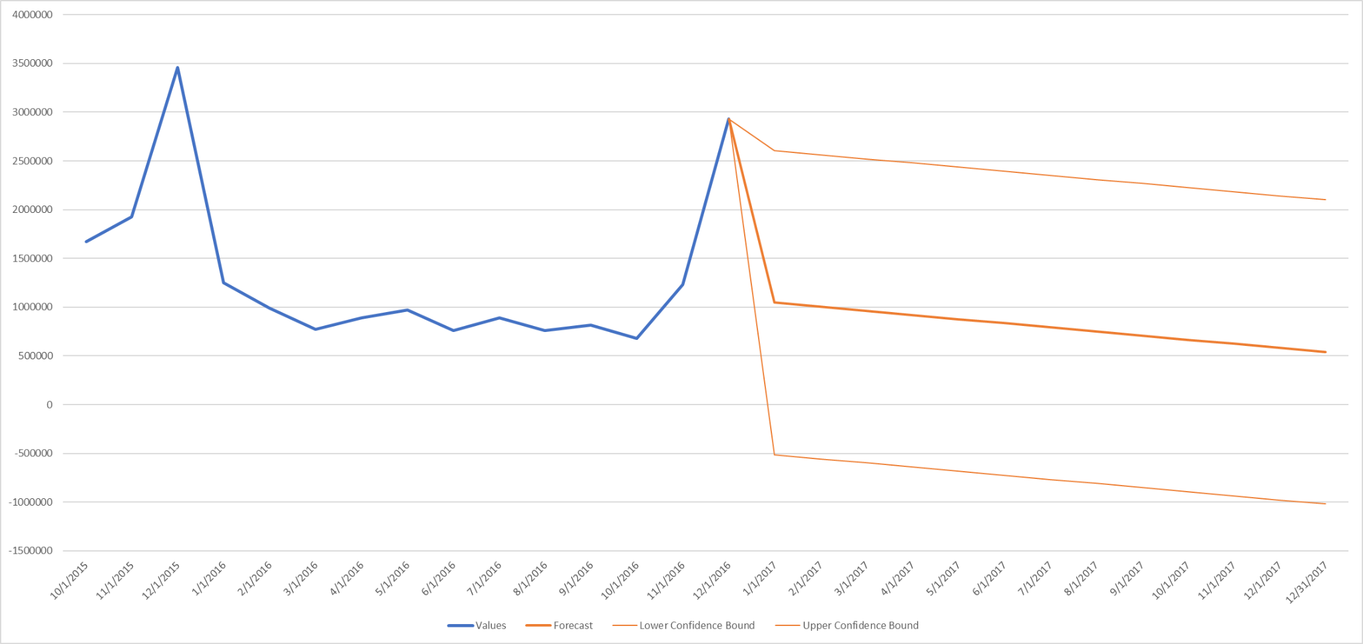

Forecast of Views

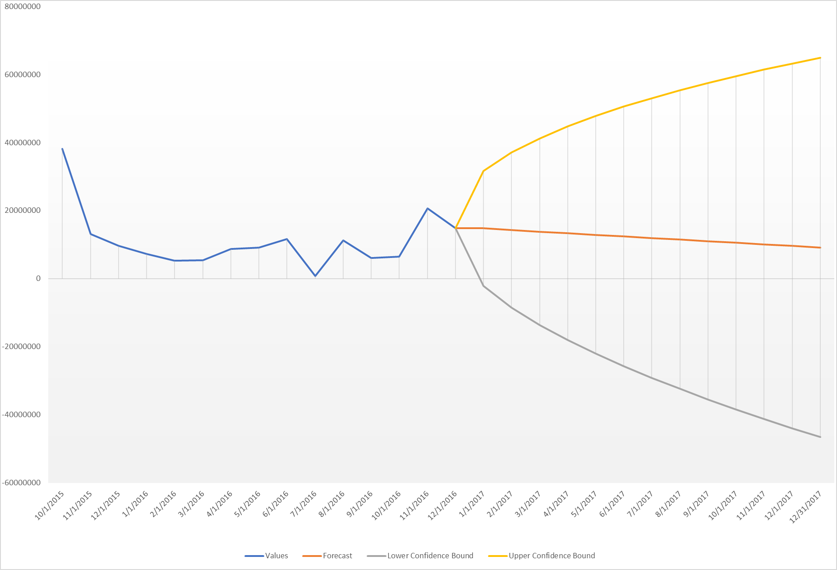

**3. Although Squatty Potty did an admirable job of creating feedback mechanisms to tie sales to views of the video, how could Squatty Potty have improved that effort? What data should the company attempt to capture through its next viral video promotion?**

Squatty Potty performed a good job regarding their feedback methods for their viral video campaign. However, a few things could have been done better for a more profound and thorough knowledge of the campaign's success. Therefore, the following information should be gathered by Squatty Potty in preparation for the next viral video campaign:

**1. Viewer-to-Customer Conversion Rates:** By keeping an eye on conversion rates, Squatty Potty can strengthen the connection between video views and actual purchases. Utilizing tracking methods like unique URLs or discount coupons .

**2. Customer Journey Analytics:** Following a customer's journey we realized that metrics such as time spent on the website, pages viewed after watching the video, click-through rates, bounce rates, and the point of exit can be used to assess a video's success.

**3. Social Media Metrics and Sentiment Analysis:** The video's acceptability and reach are clearly demonstrated by social media participation metrics. Likes, shares, comments, and mentions are some of the metrics that are tracked for the video. Sentiment analysis can be used to gain an understanding of how the video and the brand were received by the audience.

**4. Customer Feedback:** This feedback can be used to find out how satisfied customers are, make changes, and provide marketing case studies or testimonials.

**5. Demographic and Geographic Data:** Understanding demographics like age, gender, and so on could help Squatty Potty better target its future marketing efforts. and the location of its viewers geographically.

**6. Attribution Modeling:** It fits into the larger marketing strategy. Squatty Potty can gain a better understanding of how credit for sales and conversions is distributed along endpoints of the conversion path by utilizing multi-touch attribution models.

**7. Surveys and Polls:** Post-purchase surveys and polls can provide information about whether the video affected the decision to buy, customer satisfaction, product criticism, and areas for improvement.

Squatty Potty can improve its understanding of its audience, optimize the effectiveness of its future video campaigns, and make data-driven decisions. Moreover, some useful information and discoveries to back up the answer provided:

**SQUATTY POTTY FINANCIALS 2016**

**Revenue**

2016 Viral Video Sales **$12,944,694.40**

Other Sales **$15,155,412.20**

Total Sales  **$28,100,106.60**

**Expenses**

2016 Viral Video Promotion Expense **$(1,985,604.33)**

Cost of Sales (Manufacturing/Shipping/Incentives) **$(9,800,000.00)**

Additional Sales, General, Administrative (SGA)  **$(11,485,604.33)**

**Total Expense $(23,271,208.66)**

**EBIDTA $4,828,897.94**

**Video promotions on Facebook and YouTube**

Video Promotion Expenditures **$2,964,921.17**

Total Views including (organic and paid views) **168,666,696**

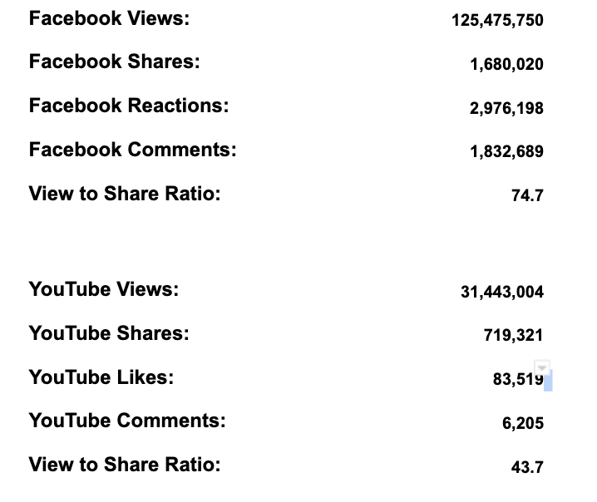

**For Promotions with Paid views**

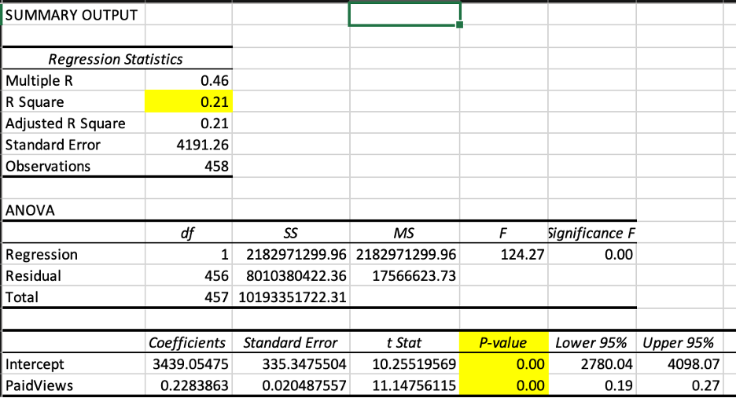

**With Promotions with Organic views**

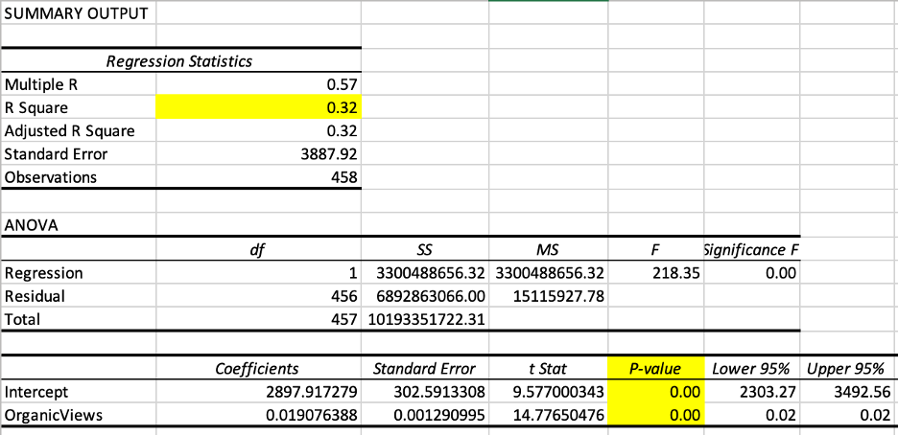

**4. What does the Facebook Targeting information in the Excel spreadsheets reveal about Squatty Potty’s market? Are there any groups either not targeted or under-represented in the targeting?**

Squatty Potty aims to leverage the Facebook platform to expand its customer base and drive more purchases. While the Facebook Targeting 2015 page provides valuable data on various gender and interest groups, it does not explicitly indicate the specific targeting groups for Squatty Potty. However, based on the extensive user base of Squatty Potty products on Facebook, it is evident that women constitute a significant portion of the target audience. To maximize its reach on Facebook, Squatty Potty intends to utilize the platform to introduce its products to a broader range of Facebook users.

Although the current data primarily derives from Facebook, it is essential to acknowledge its one-sided nature. By considering the preferences and behaviors of individuals aged 18 to 40 interested in Yoga and Veganism, Squatty Potty can identify a repositioning opportunity for its target audience. Additionally, since constipation affects many children in the United States, mothers hold a significant influence as consumers. Therefore, if Squatty Potty wishes to continue targeting mothers, it should focus on engaging a more significant number of moms. Moreover, reaching out to females with children with the interests above would be beneficial, as this would likely yield more effective results.

Squatty Potty should extend its data collection efforts beyond Facebook to address data collection limitations. Instagram and Twitter, two prominent social media platforms in the U.S., offer a more extensive user base and can provide insights into people's behaviors and mentions related to Squatty Potty products. By leveraging these platforms, Squatty Potty can enhance its brand awareness and devise strategies for future advertising campaigns.

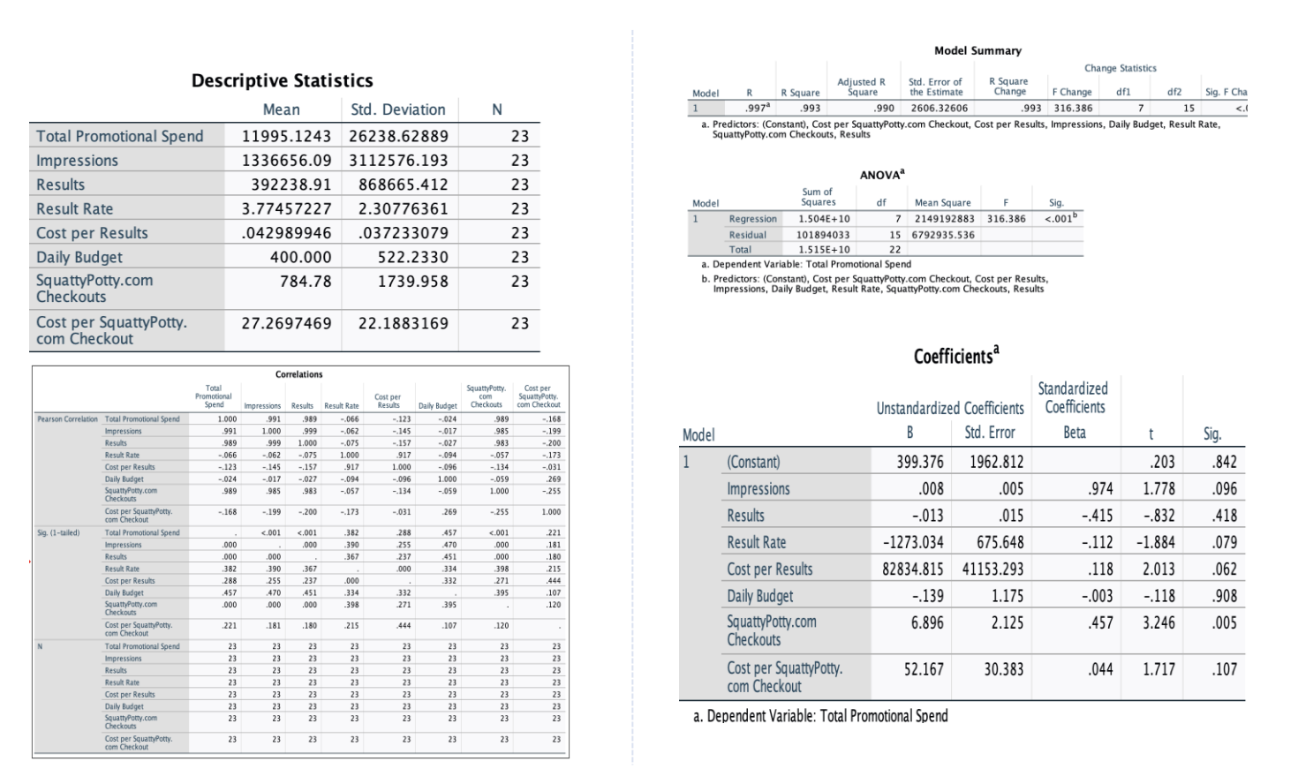

We run the linear regression, which shows positive correlations and a significant coefficient on Facebook promotional spending, which provides the data points on increasing social media marketing and impactful returns from Facebook marketing.

**5. Given what you have learned from the data, what ideas do you have for Squatty Potty’s future promotional campaigns?**

After analyzing the data collected from the Squatty Potty commercial, it is evident that there are many impressions in the Male department, along with Females, who are responsible for the highest expenses incurred by the company, each amounting to $2000. Interestingly, the age group between 18-60, irrespective of gender, generated a staggering 14 million impressions, despite the relatively low result rate. This outcome is remarkable, considering the budget allocated was only $500. In future marketing campaigns, it would be wise for Squatty Potty to target this demographic again, aiming to increase the number of impressions and the result rate. They should consider allocating a higher budget to this market segment while reducing it to another segment that yields fewer results.

The analysis also highlights the value of viral videos as a successful strategy for Squatty Potty. Not only do they promote brand awareness, but they also generate substantial profits. Therefore, producing more viral videos and expanding their distribution across various platforms should be a priority for future campaigns. Collaborating with celebrities and online influencers has proven effective in driving traffic to Squatty Potty's website and stimulating purchases, as evident from the data showing purchases made by Jessica Alba, Gwyneth Paltrow, and Howard Stern fans in 2015. This strategy should be continued by seeking partnerships with additional influencers in future campaigns.

Furthermore, social media presents numerous opportunities to showcase Squatty Potty's products. With approximately 120 million views on Facebook from October 2015 to December 2016, of which approximately 75 percent were shared, it is clear that advertising on more social media platforms such as Instagram and Twitter can further expand the brand's reach. Expanding their presence across these platforms should be considered for future marketing initiatives.